2023 UBIT Student Experience Survey

Executive Summary
7/15/2024
UBIT Communication and Engagement
Office of the VPCIO
UB Information Technology

Introduction 2
About the Survey 2
Survey Results: Highlights and Trends 3
Part 1. Students and the Technology they Use 3
Part 2. Wi-Fi and Technology in the Classroom 10
Part 3. Level Up/Silverman/Public Computing Sites 13
Part 4. Virtual Reality 15
Part 5. Computing Skills and Social Media 17
Conclusions 20

Introduction

Consistent with our recent surveys, UB students are increasingly reliant on various forms of technology, from apps to video conferencing to devices to go about their daily activities at the University at Buffalo.
Now in its 27th year, the UBIT Student Experience Survey heard from a wide range of UB students, with 39% of respondents enrolled in the school of Engineering and Applied Sciences. Other well-represented areas include the College of Arts and Sciences (17%), School of Management (11%), and the School of Public Health and Health Professions (7%).
There are some notable variances in the numbers from last year’s survey. For instance, in 2022, 97% of responding UB students reported owning their own laptop. In 2023, that number dropped to just under 82%. Last year, 60% of students reported that their laptop was purchased in the last two years. In 2023, 60% of students said their laptop was at least three years old, with 16% saying it was over six years old.
As in years past, the 2023 UBIT Student Experience Survey provides a roadmap for how UBIT can improve services and products to better meet student needs. UBIT offers discounts on laptops for students and public computers scattered across campus to assist students who do not have a laptop. UBIT also provides access to software for students via the UBIT website, services like My Virtual Computing Lab and My Virtual Public Site, and public computers on campus.
Furthermore, based on the results of the survey, students continue to be tech savvy, and expect UBIT to be as well. While it can be challenging to keep up on the ever-changing world of technology, it’s a goal UBIT is more than prepared to tackle.

About the Survey

4,139 UB students responded to the 2023 survey, representing undergraduates at all levels, as well as graduate students and non-degree seeking students. Nearly 76% of the students who responded to the survey live off-campus.
The 2023 UBIT Student Experience Survey was open from October 23 through November 6, 2023, and contained 41 questions designed in conjunction with instructional and support IT staff in each technology area surveyed, as well as the UB offices of Student Life, Campus Living, Undergraduate Education, University Libraries, and other campus stakeholders.
Responses were collected using Qualtrics. Students were encouraged to participate through social media and online promotions.
Where possible, this report compares data from 2023 with previous UBIT student surveys.
While some key questions were required, many were not; where applicable, percentages reflect the number of students who answered that specific question.
The full survey results can be found in a companion document, “2023 Raw Frequencies (PDF),” on the UBIT website.

Survey Results: Highlights and Trends

Part 1. Students and the Technology they Use

Q7 - Is your laptop working well enough to meet the needs of your coursework at UB?
In terms of whether their laptop worked well enough to meet the needs of their coursework at UB, 79% of students said their laptop met their needs, with 21% saying it did not. This is a noticeable decline as 92% of students reported that their laptop met their needs the prior year.

Q8 - Most UB students use a personal laptop for their coursework. What is the reason you haven't purchased one?
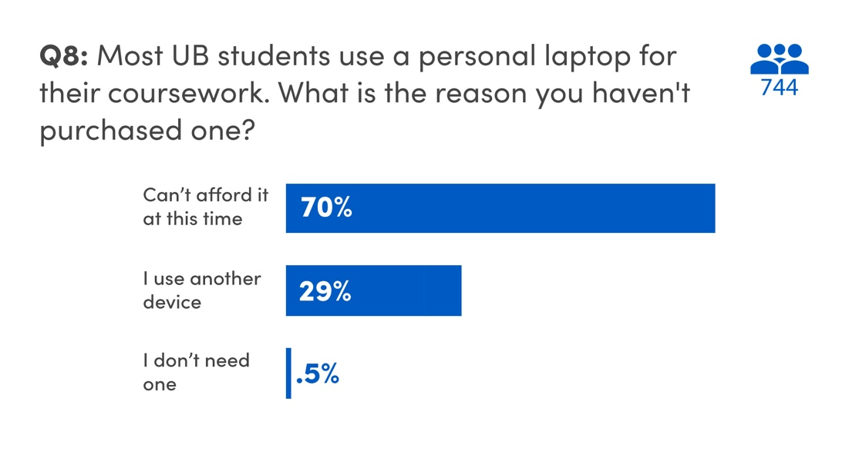
Just over 70% of students who reported not owning a laptop said cost was the main reason, which is a 10% jump from 2022. While some students chose tablets, iPads, or desktops for coursework (29%) or claim no need for a computer in classes (.5%), UBIT will monitor this trend.
Q10 - What other devices do you own? (Select all that apply.)
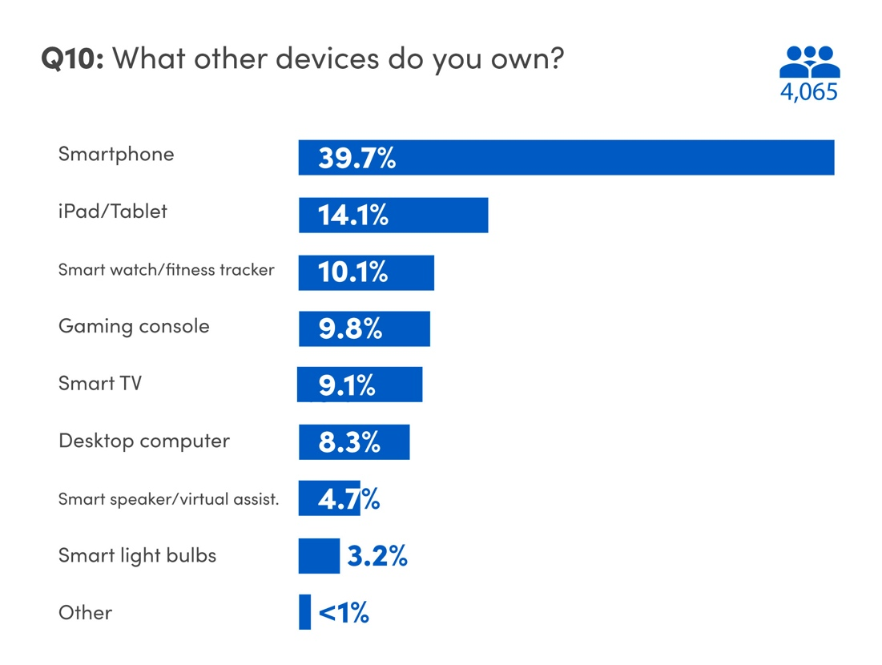
The use of smart TVs, speakers, light bulbs, and gaming systems continue to trend upward at UB. Students are also using virtual assistants at a greater rate than in the past.
As streaming takes over traditional cable, UBIT continues to ensure network access for popular smart devices, while maintaining UB’s security standards. Furthermore, upholding a high standard for Wi-Fi networks holds strategic value for student satisfaction and retention.
In 2023, UBIT launched an ongoing campaign to continue encouraging student use of the eduroam Wi-Fi network.
Q25 - Which of the following productivity software titles do you use for your studies or
coursework at UB? (Select all that apply.)
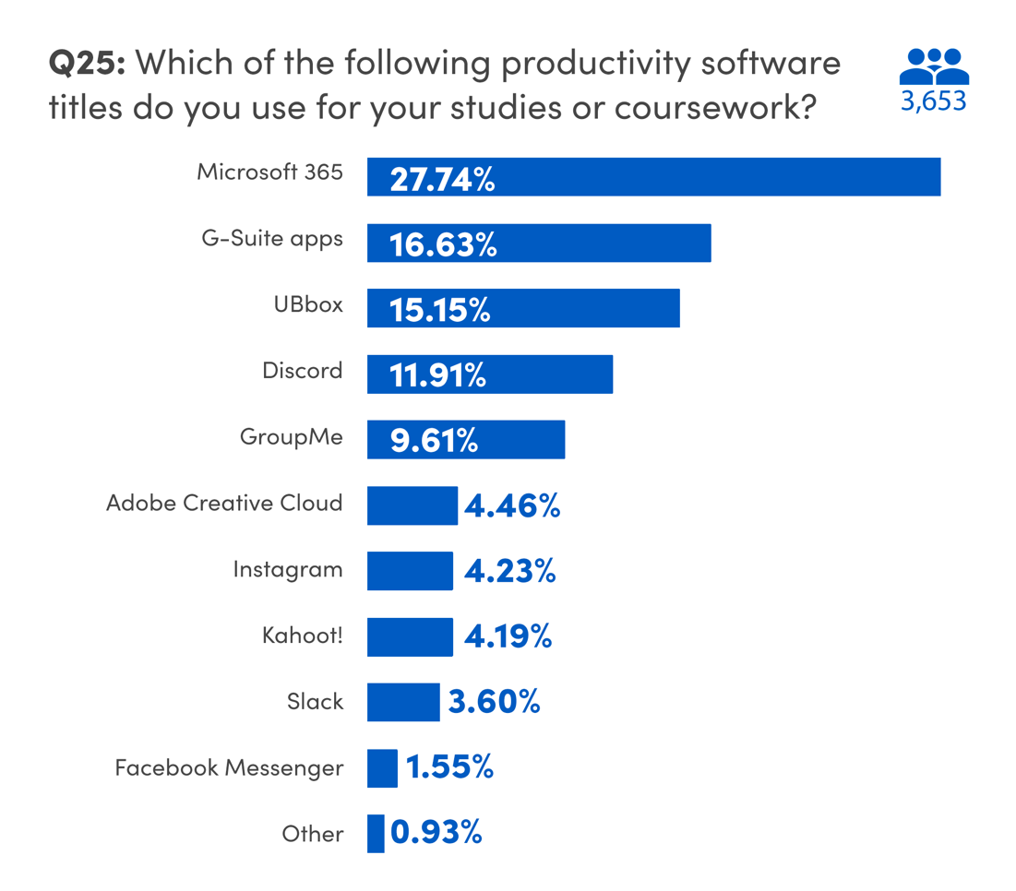
Microsoft 365 (28%) and G-Suite apps (just under 17%) are the software titles students report using most. (Microsoft 365 is available to students who started at UB during or after Summer 2021; G-Suite to those who began prior).
Students continue to use third-party messaging and group collaboration applications, with use of Discord seeing an increase from 10% in 2022 to 12% in 2023. GroupMe usage slightly decreased from 13% to just under 10%. Additionally, students engage with platforms like Instagram, Slack, Adobe Creative Cloud, Kahoot!, and Facebook Messenger, albeit to a lesser degree.
Approximately 15% of UB students indicated reliance on UB Box for their academic tasks. Other applications and software mentioned by students for coursework encompass WhatsApp, Canva, Apple Pages, and Rhinoceros 3D.

Q28 - How did you find out about UB collaboration tools and free software, such as Microsoft Office? (Select all that apply.)
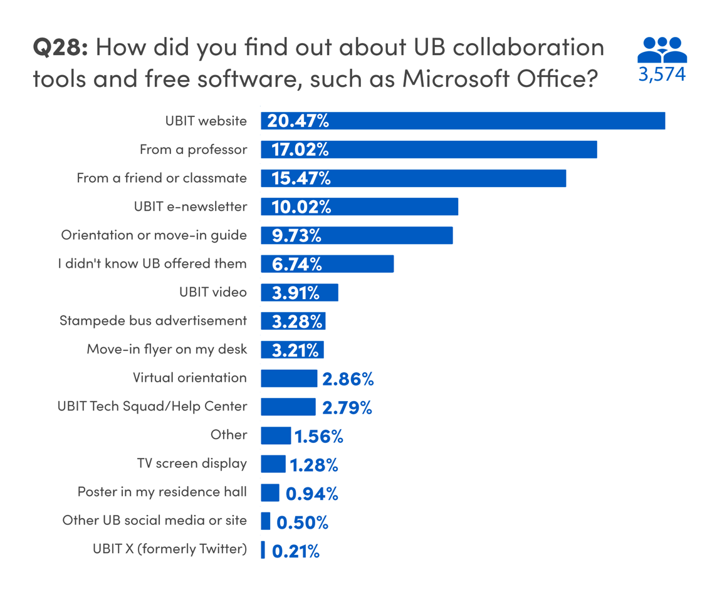
There are a variety of ways students learn about UB-provided collaboration tools and free software, including Microsoft Office. For the seventh straight year, most students reported that they learned about UB-provided tools and software through the UBIT website (20%). Just over 17% of students learned about the tools and software from a professor, while 15% were informed by a classmate or friend.
UBIT's monthly student e-newsletter, The Monthly Download, played a role in informing 10% of responding students about available software and tools during the fall and spring semesters. New student orientation or the move-in guide also informed 10% of respondents. These numbers are nearly identical to our 2022 data.
On the flipside, just under 7% of students were unaware that UB offered collaboration tools and free software to students, which is a reduction from 9% unaware in 2022. Through campaigns like the recent “Top 5 Hidden UBIT Secrets,” UBIT remains committed to expanding efforts in reaching out to students to ensure awareness of the software and services offered by UB.
Q26 - Which academic website have you signed up for during your academic career at UB? (Select all that apply.)
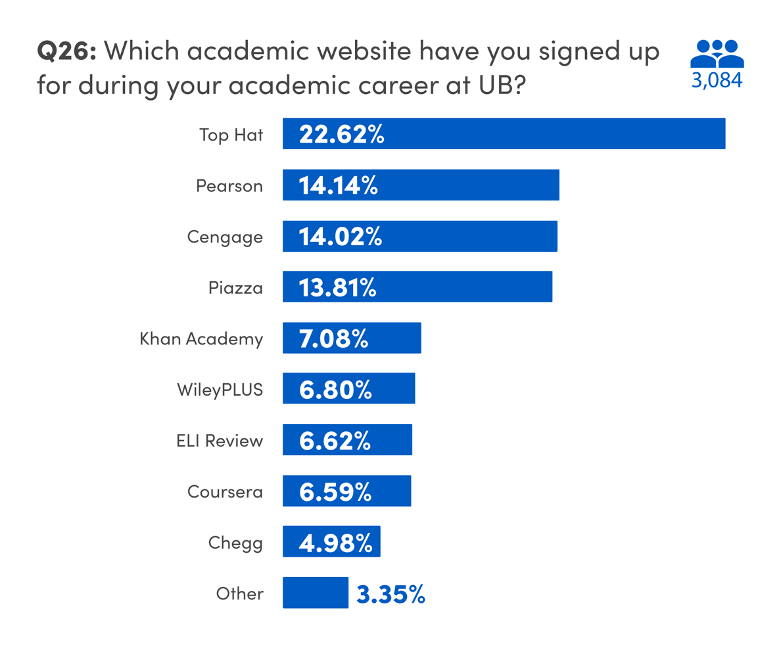
UBIT surveys students about third-party academic websites to assess the demand for support for tools, either at the institutional or departmental level, as their usage increases. The use of third-party sites, particularly those not supported by UB and lacking UB’s single sign-on protection, presents security concerns. Many students use their UB email address and password as login credentials on these sites. UB’s Information Security Office remains vigilant in monitoring third-party vendors for potential security breaches.

Q38 - What technology information did you learn about before arriving on campus? (Select all that apply.)
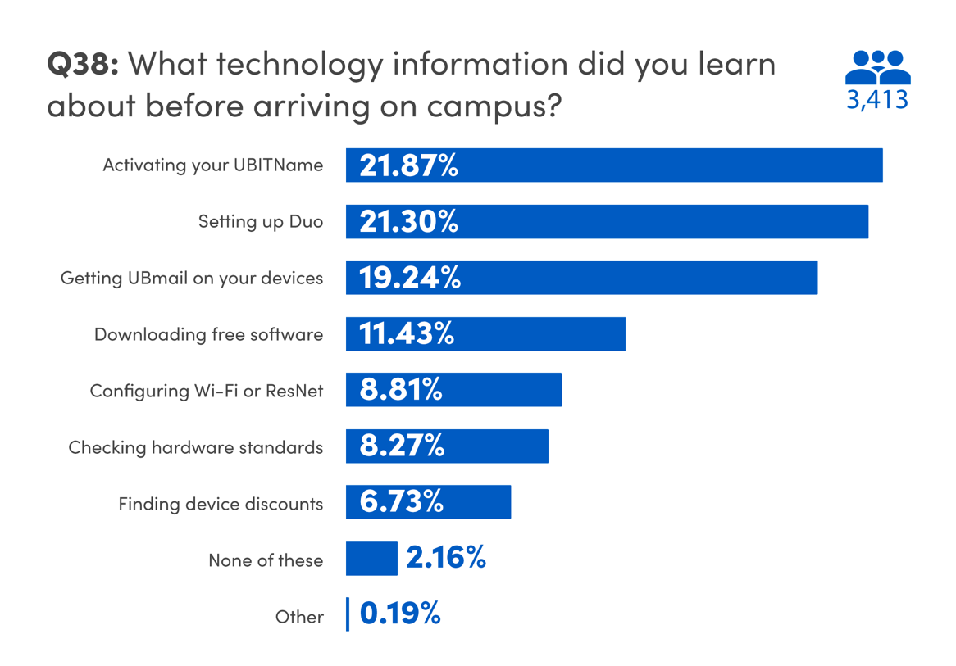
Some students choose to learn about the tech at UB before arriving on campus. About 22% of students said they learned how to activate their UBITName before coming to campus, while 21% learned how to set-up Duo two-step verification. Students were also interested in learning how set-up UBmail on their devices, with 19% taking care of that before arriving at UB. These numbers are in line with 2022’s survey.
Q39 - What technology steps did you complete before arriving on campus? (Select all that apply.)
A significant percentage of students followed through to set up UBIT software and tools prior to arriving on campus: 24% activated their UBITName, 22% set up Duo, and 20% configured UBmail on their devices.
While fewer students engage with free software and apps (10%), set up Wi-Fi or ResNet (7%), or check hardware standards (9%) pre-arrival, only 2% reported not addressing any technology tasks before reaching UB.

Q40 - Where did you learn about UB technology information before arriving on campus? (Select all that apply.)
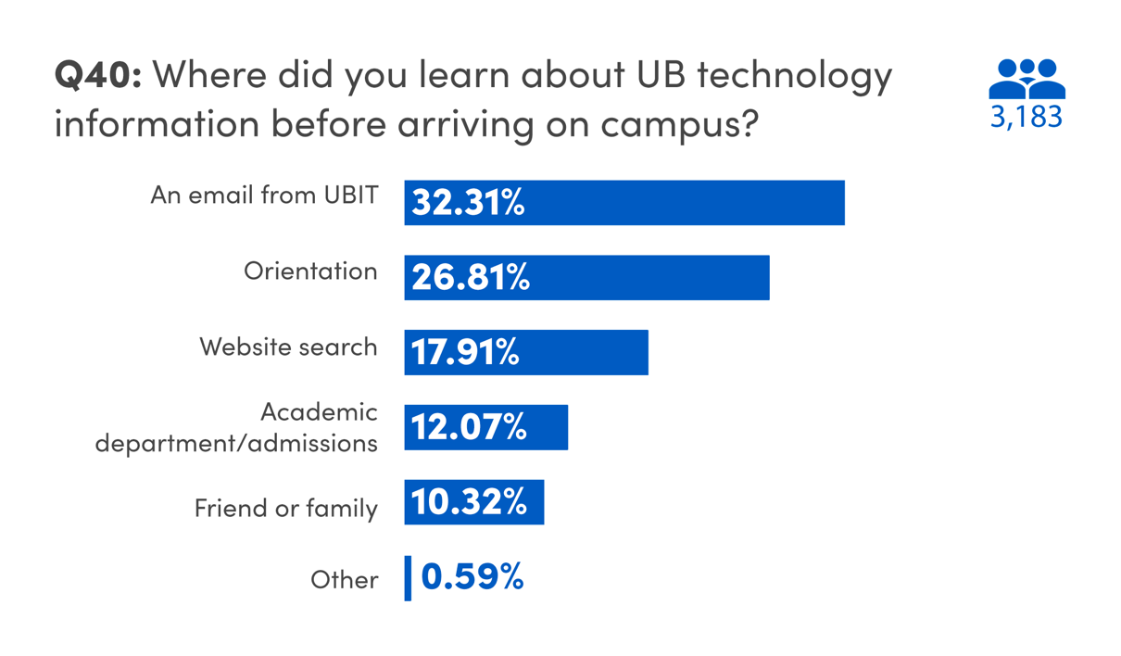
Students said they learned about tech at UB before arriving on campus from a variety of sources. 32% of students said they learned about technology at UB from an email from UBIT. Nearly 27% reported hearing this information during orientation, while 18% said they did a web search to learn about UB technology. To a lesser extent, 12% of students said they learned from their academic department or admissions, and 10% heard this information from a friend or family member familiar with UB.

Part 2. Wi-Fi and Technology in the Classroom

Q14 - Have you had any significant problems with the Wi-Fi (eduroam) this semester?
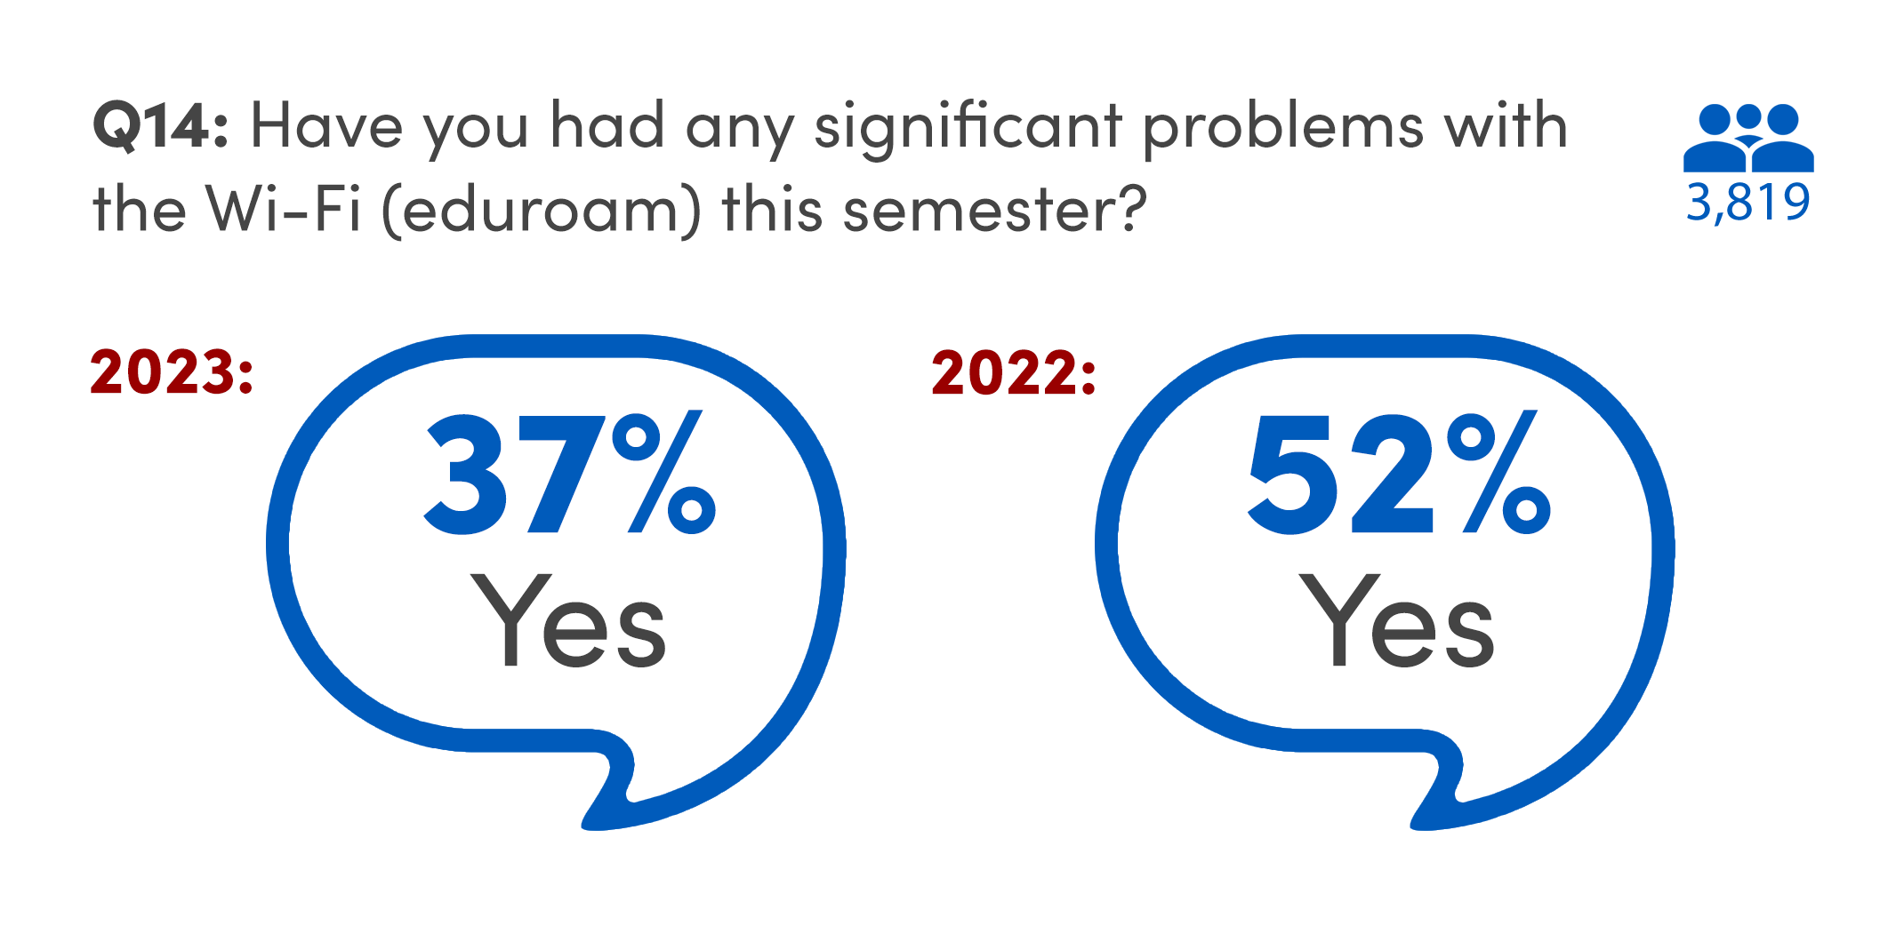
In our 2022 survey, nearly 50% of students reported having a significant issue with the Wi-Fi on campus. This year, however, the number fell to 37%, with 63% reporting no significant problems with UB’s Wi-Fi.
According to a national survey conducted by EDUCAUSE on technology issues in 2023, 42% of students nationwide said they were “dissatisfied” or “very dissatisfied” with the quality of Internet service on their campuses.
With an over 11% difference in Wi-Fi satisfaction from the previous year, the stability of UB’s networks, and the staff who work behind the scenes to keep them running, deserve credit.
Q15 - What were you doing when you experienced Wi-Fi problems? (Select all that apply.)
Similar to last year, approximately 38% of students reported problems with Wi-Fi while using UB Learns.
Nearly 18% of students faced problems streaming video for classes through Zoom or Panopto, and 14% encountered problems streaming video for entertainment. Additionally, students reported difficulties with social media, streaming audio, managing coursework on various platforms, and establishing the initial Wi-Fi connection.
Over the past year, UB’s Wi-Fi was upgraded across the campus. Additionally, a campaign to further encourage students to use the eduroam network was undertaken. The latest updates on enhancements and changes to UB’s network can be found in the UBIT News section online.

Q29 - How well does the technology in UB classrooms assist in your learning?
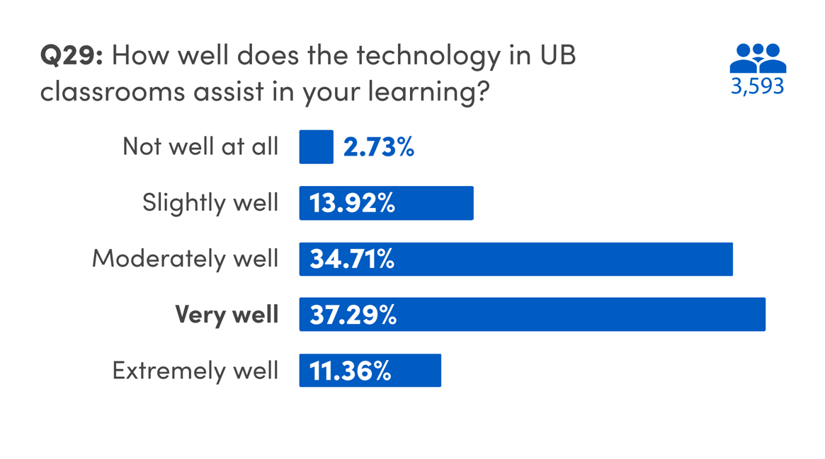
Regarding the effectiveness of technology in UB classrooms, 37% of students reported that it aided them "very well," 35% mentioned it helped "moderately well," and 11% expressed that it was "extremely helpful." Less than 3% of students said the technology in UB classrooms assisted them “not well at all.” These numbers align with 2022’s survey results.
Q30 - What technology improvement would you most like to see in UB classrooms?
About 30% of UB students said they would like to see better Wi-Fi in UB classrooms. Just under 24% would like better visibility for teaching materials in classrooms, while 19% would like to have better audio for instructors in the classroom. Conversely, 13% of students said the classrooms at UB don’t need any improvements.
In recent years, UBIT has modernized central classrooms by integrating on-demand livestreaming and lecture recording through Zoom and Panopto. Recent upgrades in classroom technology in NSC 201 and 225 included the following features to enhance interaction and engagement:
- A 30-foot video display with the capability to showcase two inputs simultaneously.
- A dedicated camera for streaming chalkboards to the main display or a remote source via Zoom or Panopto.
- Microphones installed at student seats.
Students also shared ideas for technological enhancements in UB classrooms. One suggestion proposed that all UB instructors uniformly use a designated program (such as UB Box or UB Learns) for course materials, aiming for consistency. Students said they would like microphones installed in all UB classrooms, more charging stations/areas in classrooms, and updated equipment.
UBIT is actively engaged in assessing and enhancing technology across UB's classrooms, addressing concerns raised by students and faculty. The results indicate positive trends from these ongoing efforts.

Part 3. Level Up/Silverman/Public Computing Sites

Q16 - Have you used the Level Up gaming site in Lockwood?
Lockwood's Level Up, UB’s premiere gaming site, launched in 2022. Level Up gives students access to various gaming consoles and an Esports arena. Informing UB students about the space is an ongoing campaign for UBIT. In the 2023 survey, 28% of students said they had used Level Up.
Q18 - Overall, how would you rate your experiences in Level Up?
Nearly 62% of students who visited the Level Up space said their experience at Level Up was “above average,” while just 3% of students said it was “below average.” These numbers are closely aligned with the 2022 survey results.
Q17 - Which areas of Level Up have you used? (Select all that apply.)
In terms of usage, 59% of students said they used Level Up for the Esports Arena, while 41% used the console gaming lounges.
Q19 - Have you used the UltraWide (widescreen) monitors in Silverman?
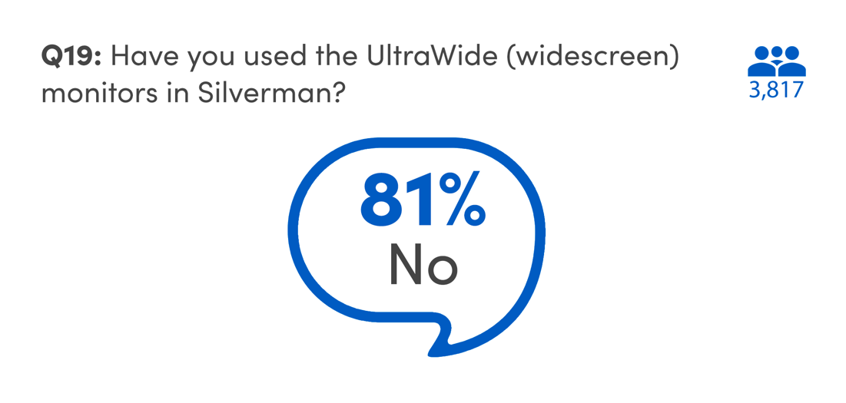
In summer 2022, the public computing site adjacent to Level Up moved to the 3rd floor of Silverman Library, where students have both PCs and Macs to choose from, as well as UltraWide monitors for students to plug in their own laptop.
About 19% of students reported using the UltraWide monitors in Silverman.
Q20 - What size UltraWide (widescreen) monitors would you prefer to use in public computing sites?
Students were also asked which size UltraWide monitor they preferred. 55% of students preferred a 38” curved LCD monitors, while 45% preferred a 49” curved LCD monitor.
Q22 - Do you use computers in the public computing sites?
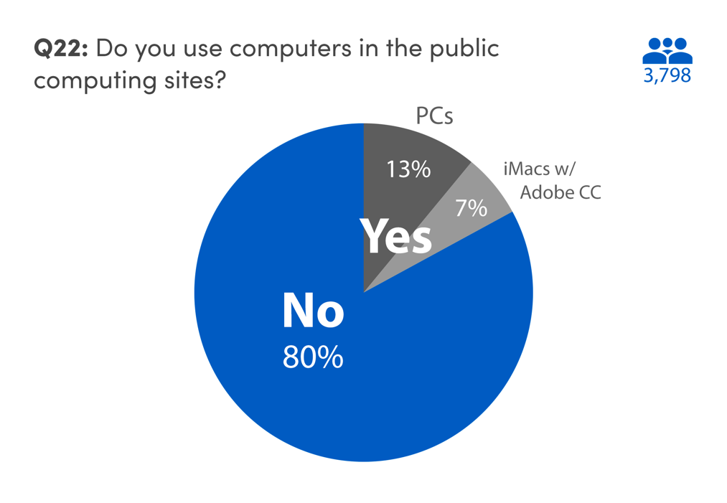
Nearly 80% of students reported that they did not use the public computing sites on campus. However, among the students who do use the sites, several themes emerged:
Just over 7% of students who use public computing sites reported using the Macs while 13% said they use PCs.
Many students mentioned using Macs for Adobe Creative Cloud applications, such as Photoshop, Premiere Pro, and other Adobe software. On the other hand, some mentioned using PCs, particularly for software like Solidworks, SAS, Microsoft Suite, and specific coding or statistical applications.
Students often mentioned using public computing sites when their personal laptops were not working, slow, or unreliable. The choice between Macs and PCs was influenced by factors like personal preference and the ability to run certain programs effectively.
Additionally, students mentioned using public computing sites for various tasks related to schoolwork, assignments, homework, group projects, and class-related activities. The availability of Macs or PCs in specific locations on campus influenced their usage.
The availability of specific software on either Macs or PCs, such as Adobe Creative Cloud on Macs or Solidworks on PCs, also influenced students' use of public computing sites.

Part 4. Virtual Reality

Q23 - How would you like to use virtual reality at UB?
When asked how they would like to use virtual reality at UB, 31% of students said they want to use it for immersive schoolwork. Nearly 28% would like to use virtual reality with video games; 21% would like to watch movies with virtual reality, and 19% said they weren’t interested in using virtual reality at UB.
Other ideas that students mentioned include virtual school trips, virtual lectures, labs, and training. Additionally, there was interest in using VR for research studies, simulations, and exploring applications.
Some students also mentioned the desire to know more about the technology's quality, having a digital twin for a realistic experience, and ensuring the tech is of high quality.
Several students mentioned the physical limitations preventing them from using VR. One student expressed disappointment about not being able to use VR for schoolwork on their desktop computer.
Q24 - How can we support the use of virtual reality at UB? (Select all that apply)
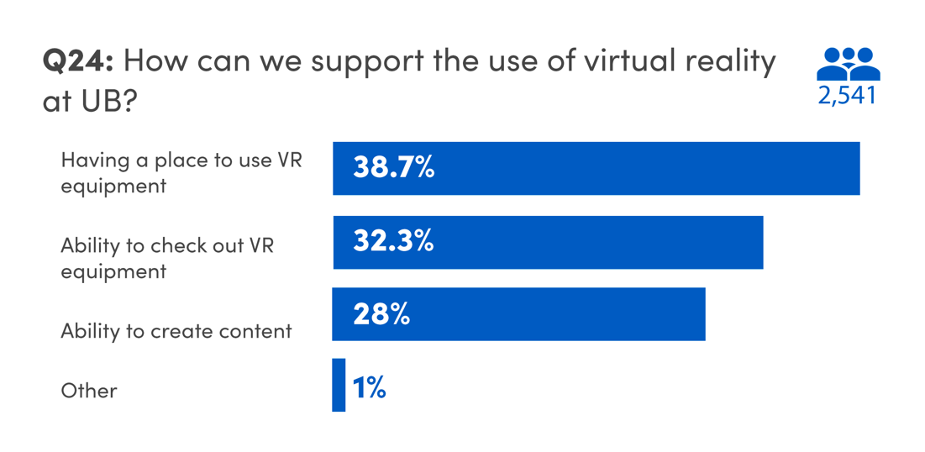
Students were also asked how UB could best support the use of virtual reality on campus. About 39% of students said having a dedicated place to use VR equipment on campus would be important. 32% said having the ability to check-out VR equipment would be useful, while 28% said they’d like the ability to create content for VR use in classes or games.
Other themes students mentioned revolve around integrating VR into their education, promoting awareness around campus, making VR accessible to online students, exploring practical applications, and fostering clubs and activities related to VR.

Part 5. Computing Skills and Social Media

Q32 - In which of the following computer-related areas do you feel confident in your abilities? (Select all that apply.)
The survey revealed that a significant percentage of students expressed confidence in fundamental computing skills (92%), using Microsoft Word (85%), typing on a computer (83%), connecting to Wi-Fi (80%), and enrolling in classes (80%). Additionally, students reported comfort in navigating UB Learns (76%) and using tablets/iPads (76%).
However, there was a slightly lower level of confidence in tasks such as ability to recognize phishing or malicious emails (70%), converting files between formats (66%), and scanning documents (61%). With few variances, these numbers are in line with 2022’s UBIT Student Experience Survey.
Q33 - What social media platforms do you utilize most frequently? (Select all that apply.)
Social media usage numbers were similar to 2022’s UBIT Student Experience Survey. The most frequently used platforms were Instagram (22%), YouTube (20%), and Snapchat (12%). Other commonly used platforms include LinkedIn (11%), TikTok (9%), Reddit (8%), Facebook (8%), and X/Twitter (6%). Additionally, in open-ended responses, smaller percentages of students cited using Discord, WhatsApp, WeChat, Tumblr, and Twitch.

Q34 - What platforms do you rely on to get the following types of UB news and updates? (Select all that apply for each category.)
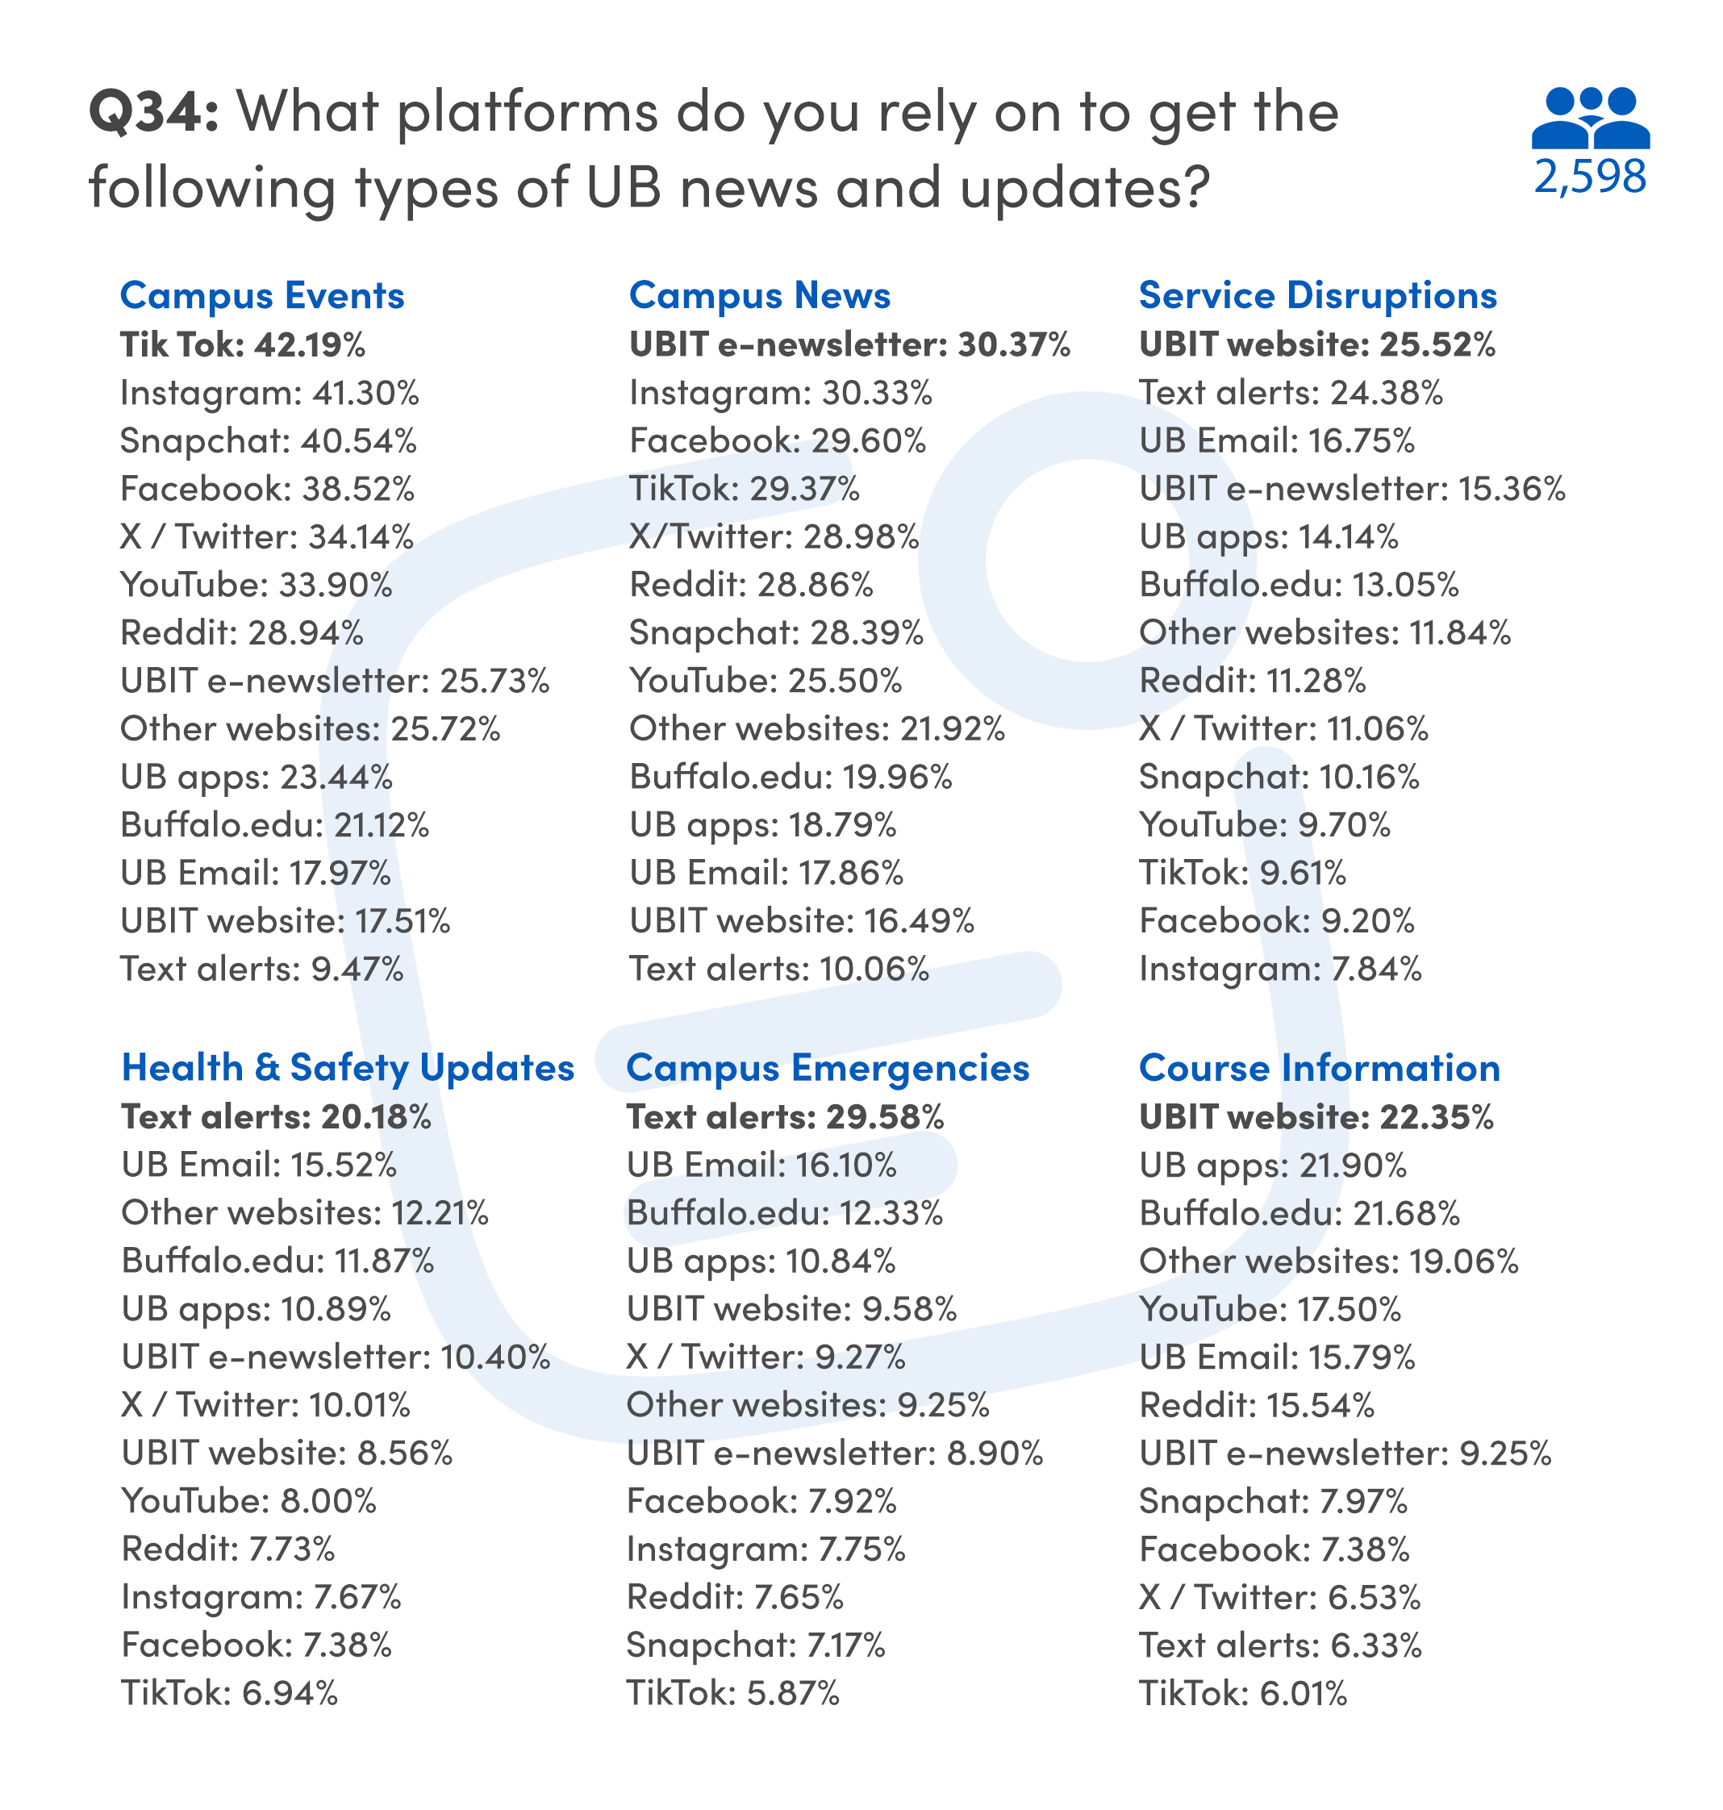
Students use various platforms to stay informed about campus news, events, service disruptions, health and safety updates, and emergencies, choosing each platform based on the nature of the message.
41% of students use Instagram to keep up with campus events. When it comes to campus news, the UBIT e-newsletter is favored by 30% of responding students, closely followed by Instagram and Facebook. This is a change from last year’s survey, where YouTube was favored for campus news.
For service disruptions, 25% of students responded relying on the UBIT website, while text alerts were the choice for health information, according to 20% of students. Text alerts are also how 30% of students said they find out about campus emergencies. The Buffalo.edu website, UBIT website, and UB apps were how 22% of students reported finding out about course information.

Conclusion

The 2023 Student Experience Survey is a great tool to gauge where students are when it comes to technology on campus. A higher number of students are reporting being unable to afford a new laptop or their existing devices aging and being unable to support their coursework. This is a change from recent, previous surveys, and UBIT will continue to monitor to ensure students have the resources they need.
Students continue to take advantage of and appreciate the tech available in their classrooms and on campus in general. The 11-point positive change in how the Wi-Fi network on campus is working for students is a sign of the work that goes on behind the scenes at UBIT.
UBIT continues to offer laptop discounts, software titles like Zoom and Microsoft 365, and other tools to ensure students have everything they need to be successful at UB. Students' feedback and support are instrumental in maintaining and enhancing the tech systems essential for their success, paving the way for a promising future.
As always, UBIT wishes to thank the students who responded to this survey and participate in our Student Advisory Group for their contribution to our work.
Visit the UBIT website to see full results and analysis from previous years’ surveys.

